**The Impact of**

**‘Shall-Issue’ law and guns on Crime Rate in the U.S.**



**Andrew Abraham**

Table of Contents

1. Introduction: 4
2. Data understanding: 4
3. Univariate Analysis: 4
4. Corellation matrix: 5
5. Exploratory Data Analysis: 5
6. Crimes across time: 5
7. Crimes across states: 6
   * 1. Violent Crimes: 6
     2. Robbery: 7
     3. Murder: 8
8. Shall carry law vs crime: 9
9. Grouping states based on adoption of Shall carry law: 10
10. Incarceration vs crime rate: 13
11. Conclusion from EDA: 13
12. Approach: 13
13. Model Building 14
14. Violent Crime Rate: 14
    * 1. Model 1: 14
      2. Model 2: 15
      3. Model 3: 17
      4. Hausman Test: 18
      5. Model 4: 19
      6. Model 5: 20
      7. Model 6: 20
      8. F-Test: 22
      9. Model 7: 23
15. Murder Rate 25
    * 1. Model 1: 25
      2. Model 2: 27
      3. Model 3: 28
      4. Hausman Test: 29
      5. Model 4: 30
      6. Model 5: 31
      7. Model 6: 32
      8. F-Test: 34
      9. Model 7: 35
16. Robbery 38
    * 1. Model 1 38
      2. Model 2: 40
      3. Model 3: 41
      4. Hausman Test: 42
      5. Model 4: 43
      6. Model 5: 44
      7. F-Test: 46
      8. Model 6: 47
17. Conclusion: 49

# Introduction:

The impact of incarceration rate and guns on crime has always engendered many public debates in America. Many states have adopted the right-to-carry laws, also known as the shall-issue laws, as an effort toward regulation of guns. A shall-carry law requires that government issue concealed carry handgun permits to any applicant who meets the necessary criteria. These criteria are that the applicant must be an adult, have no history of mental illness and no significant criminal record and should successfully complete a course in firearms safety training (if required by law). If these criteria are met, then the granting authority has no discretion in awarding the license. Many believe this would lead to lower crime rates as restrictions would be placed to own a gun. Whereas, many others who are against this law suggest that crime rate would increase as criminals would be more willing to commit a crime since there would be fewer guns issued, which would have been a threat to them.

The objective of this report is to evaluate the effect of higher incarceration rate and the effect of the shall-issue law on the reported crime rate, specifically robbery rate, murder rate and violent crime rate (all measured as incidents per 100,000 members of the population). A balanced panel of data of the 50 states of the United States, plus the District of Columbia, from 1977 through 1999 is used for the analysis.

# Data understanding:

We started out by performing a univariate analysis to gain an understanding about the variables in the dataset.

Missing data: There were no missing data to be dealt with.

## Univariate Analysis:

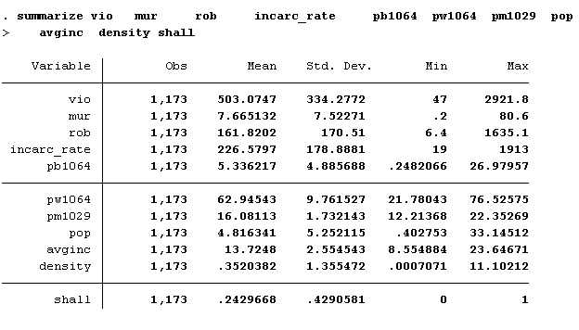

## Corellation matrix:

We created a corelation matrix to understand the relationship between variables. On a broad level all types of crimes are strongly corealted to each other. Percentage of white population is negatively corelated with crime and percentage of black population is positively corelated with crime. Population density has a strong corelation with crime whereas averageincome has a weak corelation.

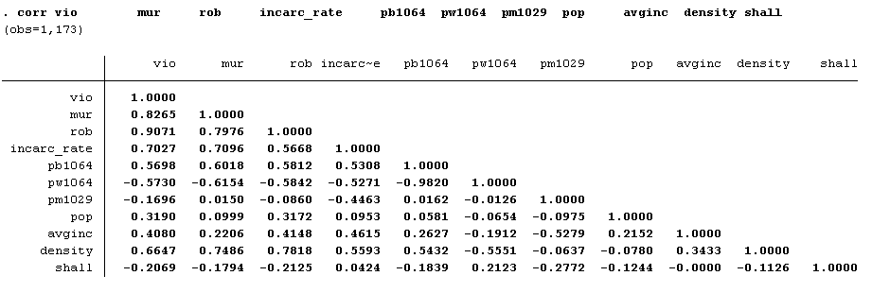

# Exploratory Data Analysis:

## Crimes across time:

First step was to understand the distribution of data across time. Here we can see that the three nationwide averages for violent crime rate, Robbery rate and murder rate all follow a similar trend across time. The distribution looks like bimodal, with a peak in crime in the years 1980 and 1991 with a trough at 1984 and continuous decrease post 1993.

## Crimes across states:

### Violent Crimes:

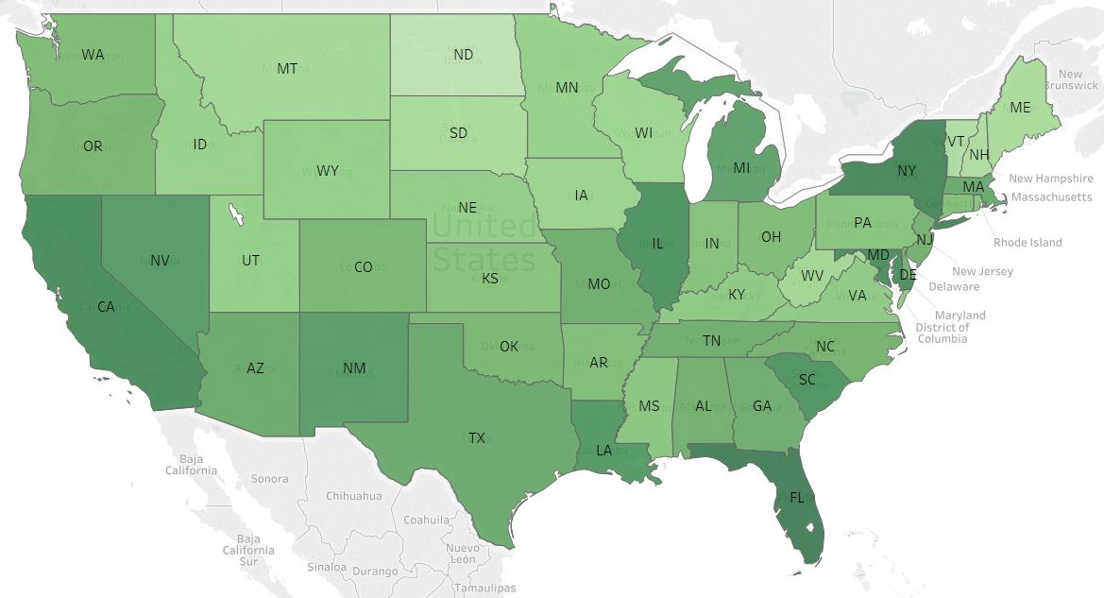

Average violent crime rate was calculated across time and the states were plotted.

Top states:

1. DC
2. Florida
3. New York

Bottom state:

1. North Dakota
2. New Hampshire
3. Vermont

### Robbery:

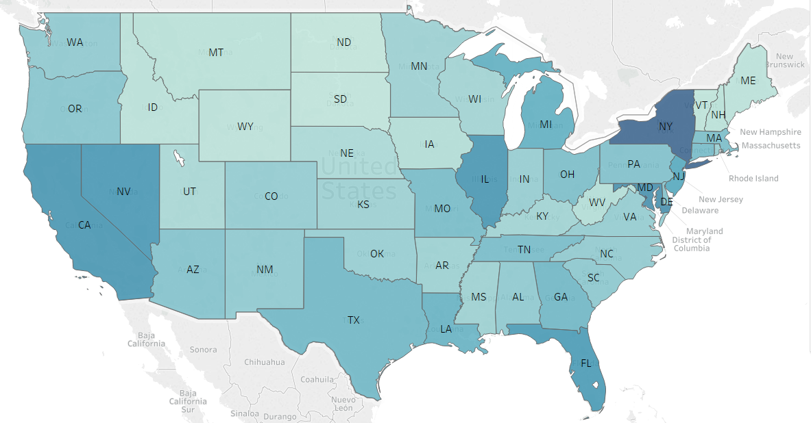

Average robbery rate was calculated across time and the states were plotted.

Top states:

1. DC
2. Maryland
3. New York

Bottom state:

1. North Dakota
2. South Dakota
3. Vermont

### Murder:

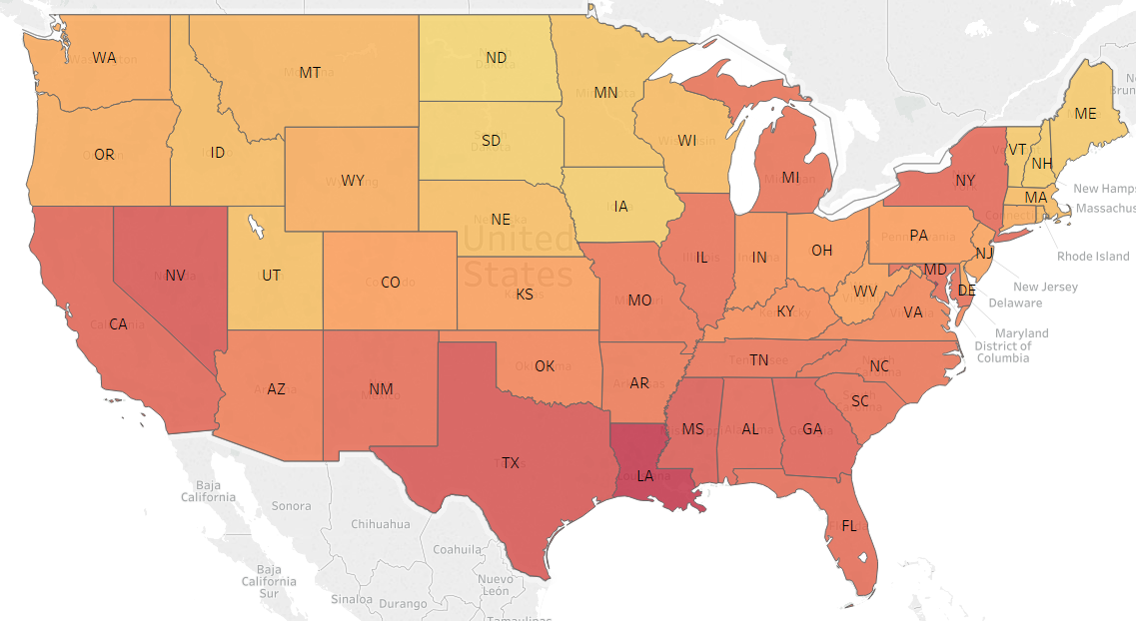

Average murder rate was calculated across time and the states were plotted.

Top states:

1. DC
2. Louisiana
3. Texas

Bottom state:

1. North Dakota
2. South Dakota
3. Iowa

Overall DC is among the top states for all three types of crimes and North Dakota is among the bottom three for all types of crimes. Most of the sun belt states have higher crime rate compared to the rest of USA.

## Shall carry law vs crime:

Nation’s average crime rate and the number of states with shall carry law doesn’t show a clear trend. In the years from 1989 to 1992 there is an increase in the number of states which passed the shall carry law however there is an increase in the nationwide average for crime. Where as from 1994 to 1997 the increase in number of states with the shall carry law is corelated to the decrease in crime. 1997 to 1999 where no new states implemented the law, there is still a decrease in the number of crimes, suggesting other variables are driving crime rate.

## Grouping states based on adoption of Shall carry law:

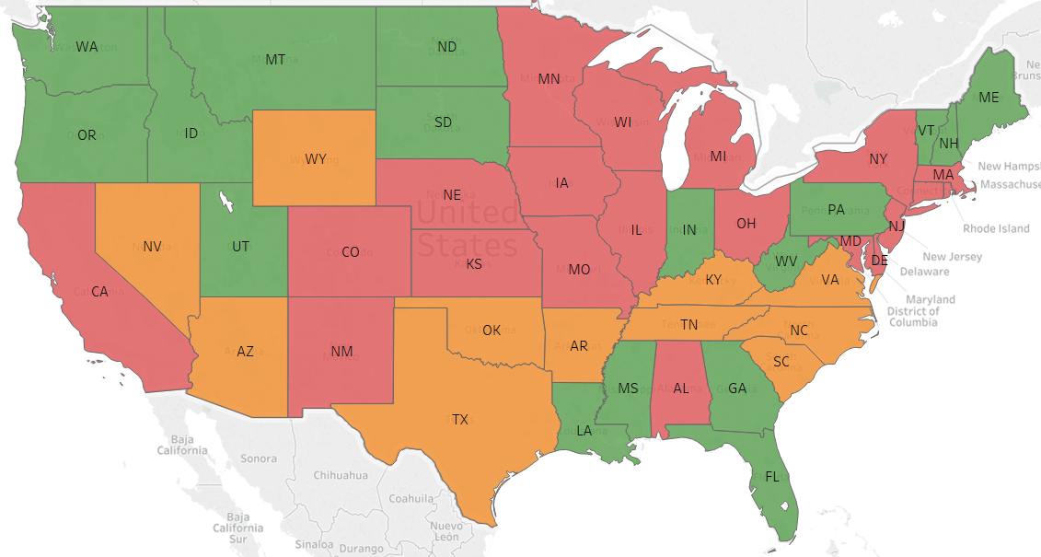

|  |  |  |  |
| --- | --- | --- | --- |
| **State** | **Average of shall** | **Percentile Rank** | **Group** |
| AL | 0 | 0 | 1 |
| CA | 0 | 0 | 1 |
| CO | 0 | 0 | 1 |
| CT | 0 | 0 | 1 |
| DC | 0 | 0 | 1 |
| DE | 0 | 0 | 1 |
| HI | 0 | 0 | 1 |
| IA | 0 | 0 | 1 |
| IL | 0 | 0 | 1 |
| KS | 0 | 0 | 1 |
| MA | 0 | 0 | 1 |
| MD | 0 | 0 | 1 |
| MI | 0 | 0 | 1 |
| MN | 0 | 0 | 1 |
| MO | 0 | 0 | 1 |
| NE | 0 | 0 | 1 |
| NJ | 0 | 0 | 1 |
| NM | 0 | 0 | 1 |
| NY | 0 | 0 | 1 |
| OH | 0 | 0 | 1 |
| RI | 0 | 0 | 1 |
| WI | 0 | 0 | 1 |

|  |  |  |  |
| --- | --- | --- | --- |
| **State** | **Average of shall** | **Percentile Rank** | **Group** |
| KY | 0.130435 | 0.44 | 2 |
| SC | 0.130435 | 0.44 | 2 |
| TX | 0.130435 | 0.44 | 2 |
| AR | 0.173913 | 0.5 | 2 |
| NC | 0.173913 | 0.5 | 2 |
| NV | 0.173913 | 0.5 | 2 |
| OK | 0.173913 | 0.5 | 2 |
| VA | 0.173913 | 0.5 | 2 |
| AK | 0.217391 | 0.6 | 2 |
| AZ | 0.217391 | 0.6 | 2 |
| TN | 0.217391 | 0.6 | 2 |
| WY | 0.217391 | 0.6 | 2 |

|  |  |  |  |
| --- | --- | --- | --- |
| **State** | **Average of shall** | **Percentile Rank** | **Group** |
| LA | 0.347826 | 0.68 | 3 |
| MT | 0.347826 | 0.68 | 3 |
| ID | 0.391304 | 0.72 | 3 |
| MS | 0.391304 | 0.72 | 3 |
| OR | 0.391304 | 0.72 | 3 |
| GA | 0.434783 | 0.78 | 3 |
| PA | 0.434783 | 0.78 | 3 |
| WV | 0.434783 | 0.78 | 3 |
| FL | 0.521739 | 0.84 | 3 |
| UT | 0.565217 | 0.86 | 3 |
| ND | 0.608696 | 0.88 | 3 |
| SD | 0.608696 | 0.88 | 3 |
| ME | 0.782609 | 0.92 | 3 |
| IN | 1 | 0.94 | 3 |
| NH | 1 | 0.94 | 3 |
| VT | 1 | 0.94 | 3 |
| WA | 1 | 0.94 | 3 |

Once the states were split based on their adoption of shall carry law, we observed some difference in trends. The group of states that rejected the shall carry law on an average has higher crime than the states that adopted shall carry. Shall carry law seems to affect murders the most as the increase in murders from 1985 – 1991 in the rejecter states is not present in the adopter states. Also, the late adopter states show a sharper drop in the number of murders form 1983 than the other two groups.

## Incarceration vs crime rate:

A bivariate between the previous year’s incarceration rate and the current years crime does not show any conclusive trends. Incarceration has been on a steady rise however crime rate has been varying.

# Conclusion from EDA:

1. Shall carry law seems to have a different impact on different types of crimes
2. Incarceration over time does not seem to have a clear impact on crime rate

# Approach:

We will create three different models with the dependent variable being each type of crime:

# Model Building

## Violent Crime Rate:

### Model 1:

We first run a Pooled Effect model with all the independent variables. The results are shown below:

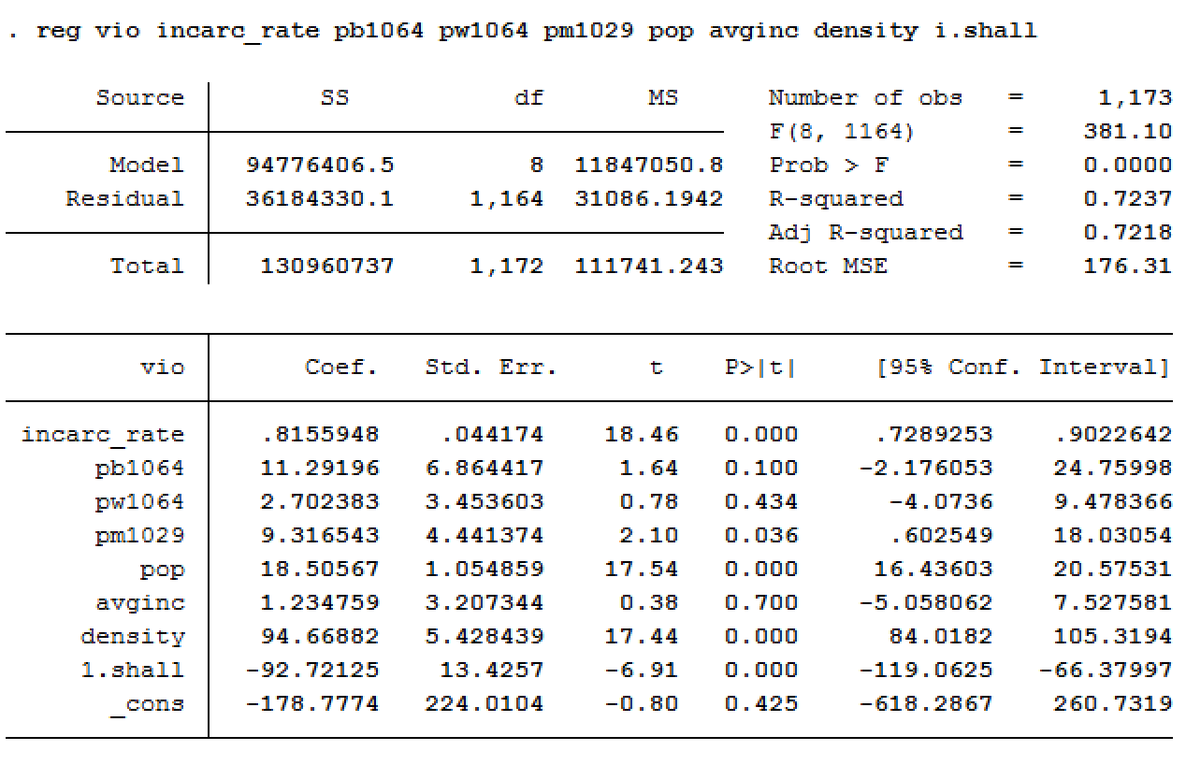

Our next step is to run the same model using the robust standard errors to account for the incorrect standard errors.

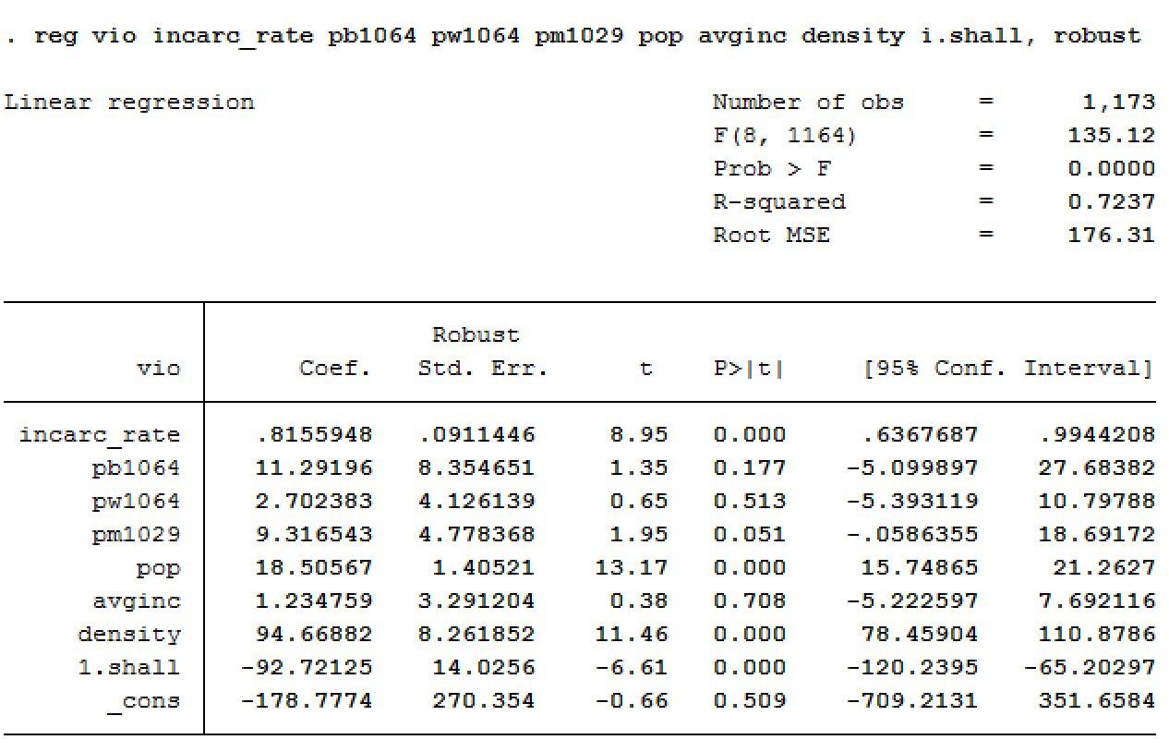

Due to the time effect included in panel data, a variable x in time t has an influence over xt+1. Therefore, the assumption that the error terms between different time periods are not serially correlated is violated. Additionally, the variance of the error term may also be different over time.

To account for the problem of serial correlation which causes the coefficient estimates to become inefficient and the standard errors to be misleading, the next step is to run the panel data as a fixed and random effects model.

### Model 2:

A random effects model is run next as it has more degrees of freedom than the fixed effect model. Below are the results from the random effects model:

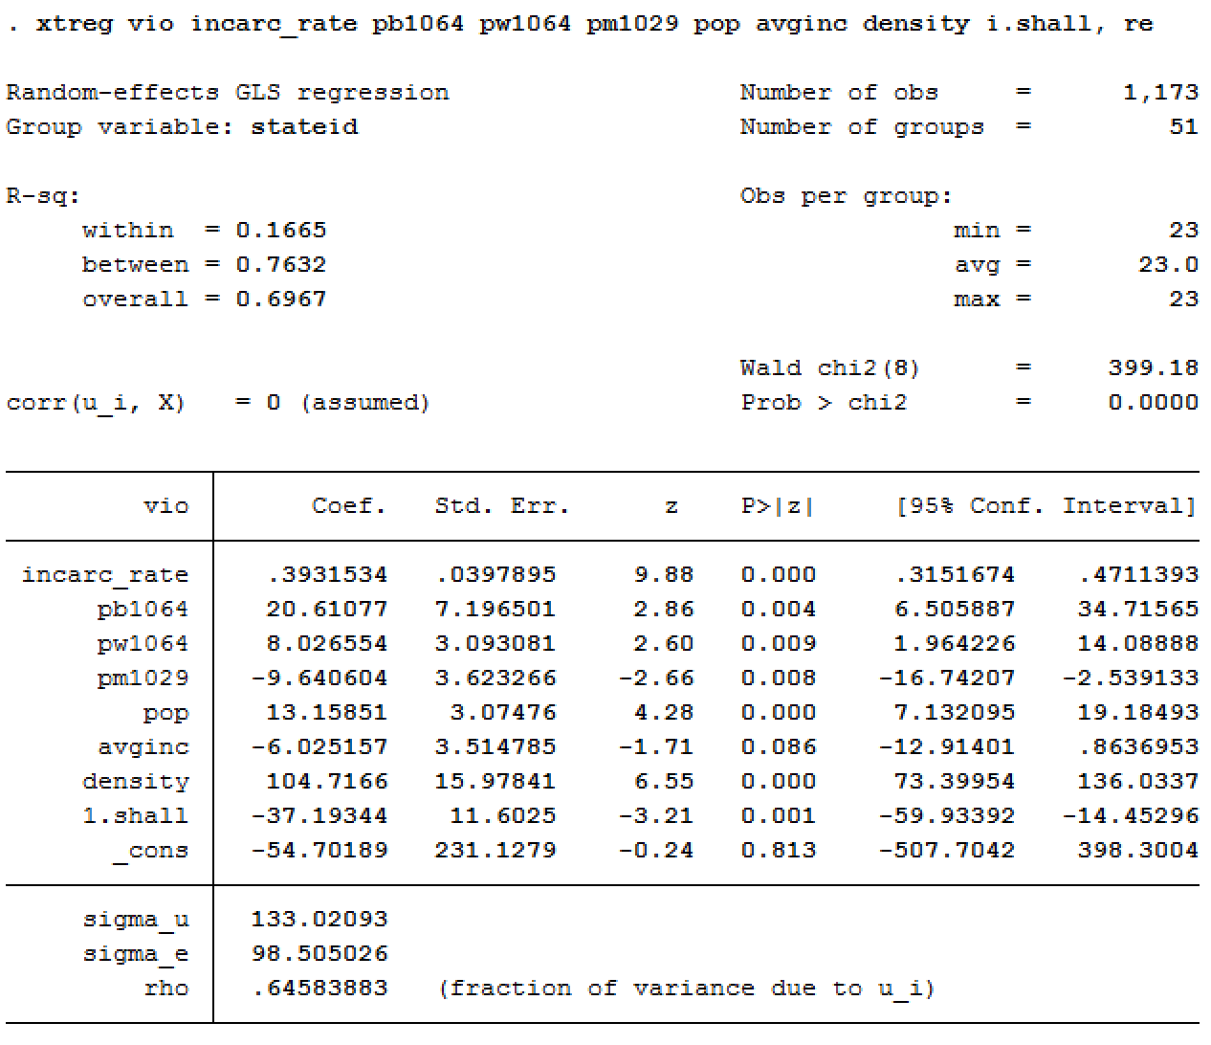

### Model 3:

The fixed effects model is run next. The results are as follows:

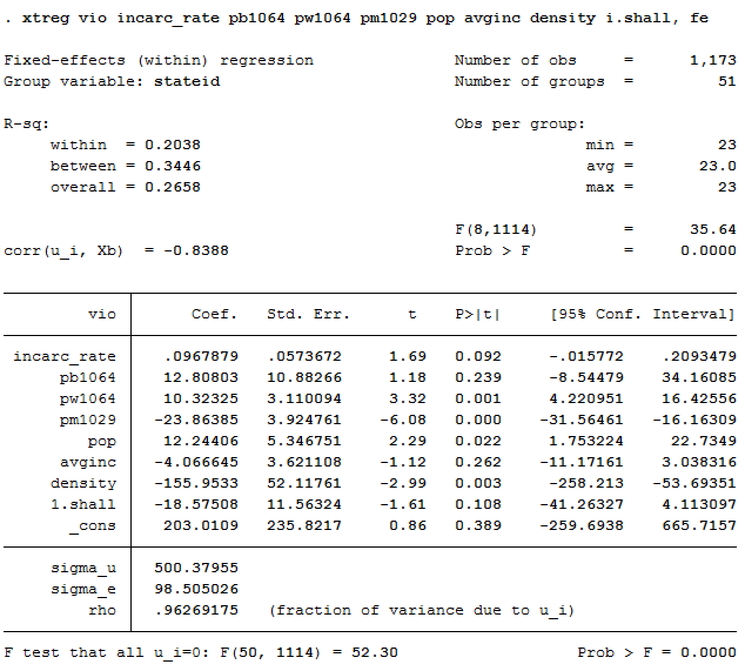

### Hausman Test:

Hausman’s test is run next to test if the independent variables of the random effects model are correlated with its error. Below are the results:

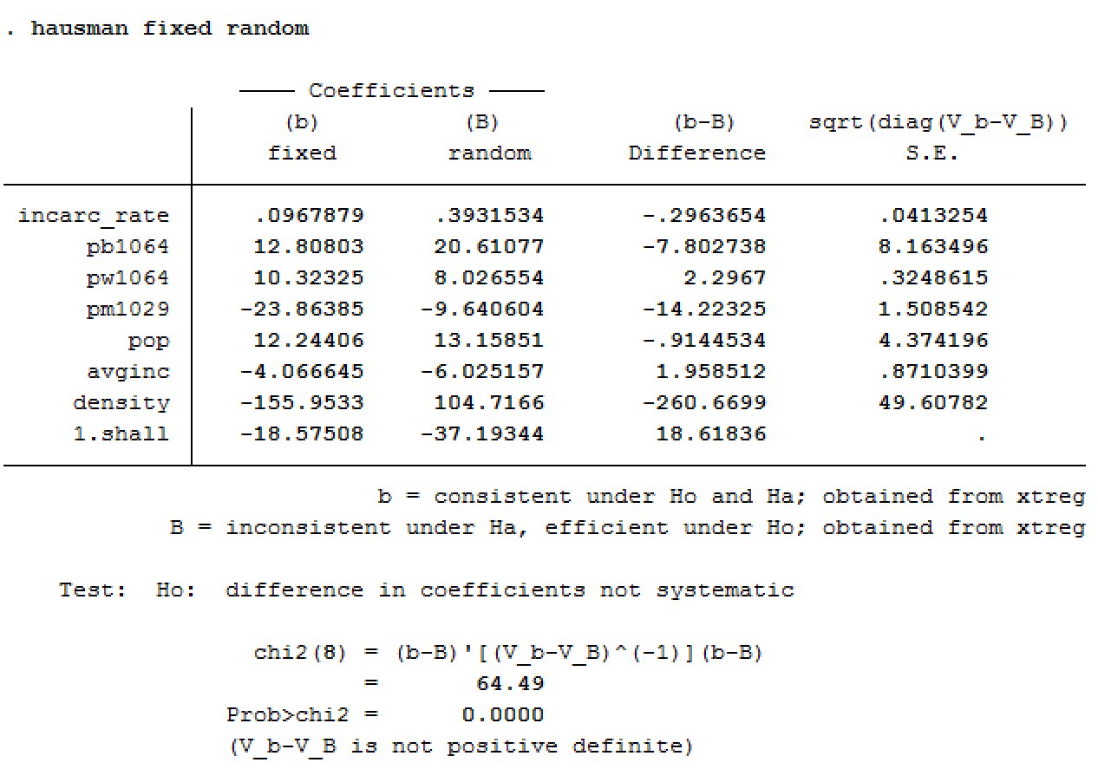

The p-value is < 0.00. So, we reject the null hypothesis that the coefficients of the fixed effect and the random effects are the same. Hence, the fixed effects model is selected.

### Model 4:

The fixed effect model is then run, with the Cluster Robust Standard Errors to get more efficient coefficients.

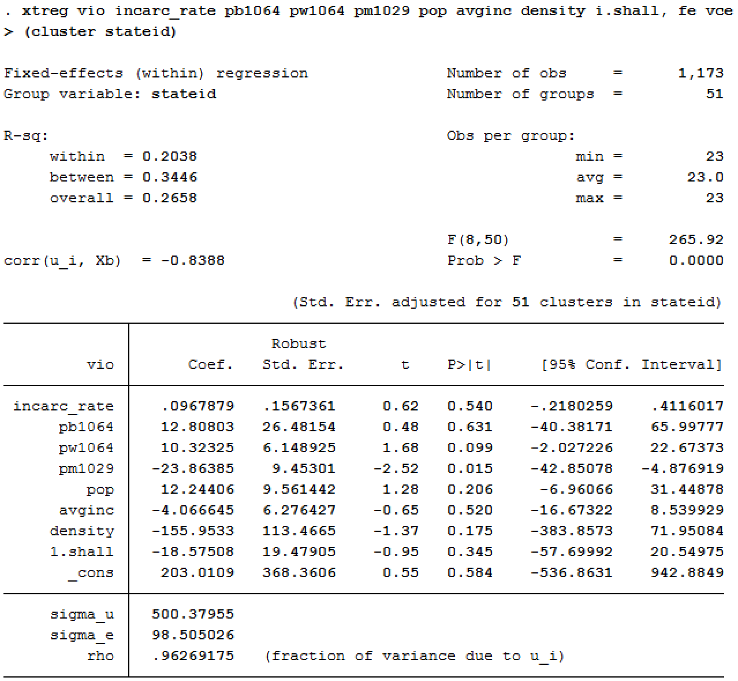

None of the variables except for the percent of males in the age group 10 to 29 (pm1029) are significant at a 95% confidence level.

### Model 5:

We then use log variables to account for the skewness observed in the histogram of the variables

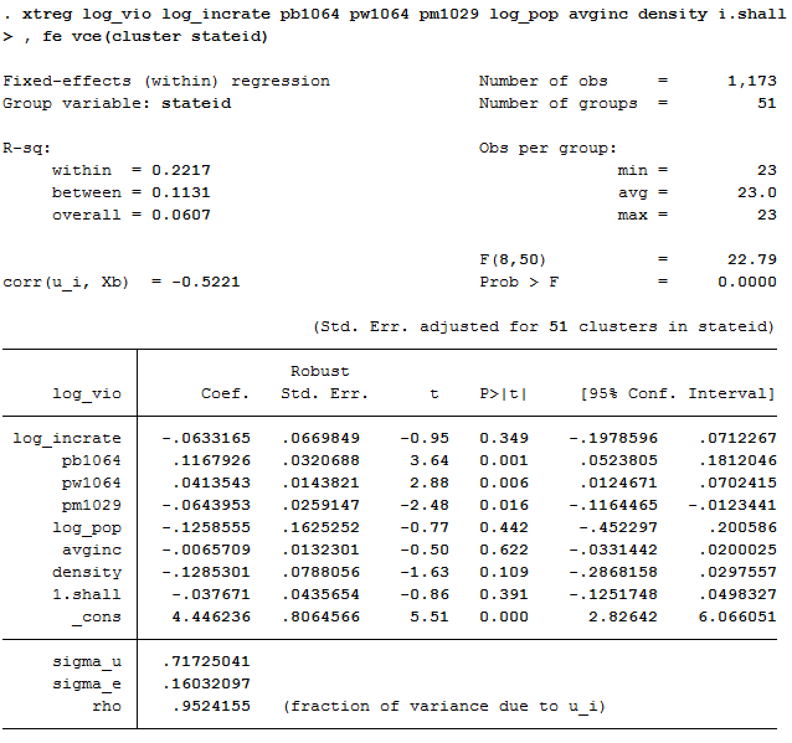

We see that both percent of black people as well as white people in the age group 10 to 64 (pb1064 and pw1064) have become significant at the 95% confidence level.

### Model 6:

Dummy variables for each year is then added to check for time effects on the fixed effects model. The results are given below:

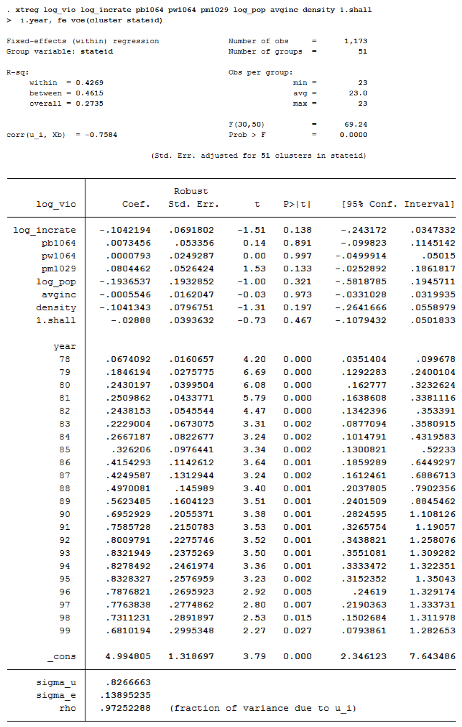

### F-Test:

An F-test is performed on the year dummy-variables, to assess if the fixed effect model is affected by the time component of the panel data.

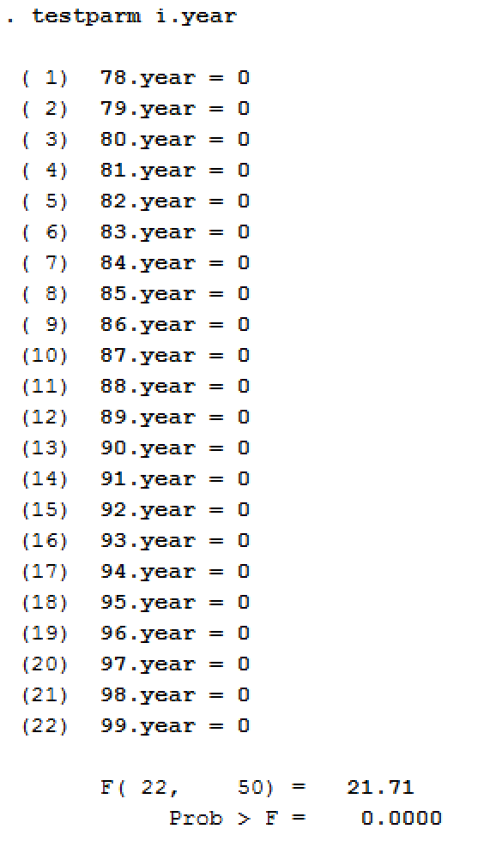

The results show that the time effects do indeed affect the fixed effect model.

### Model 7:

To understand the effect of non-linear relationship of the independent variables on violent crime rates, interaction variables were added. The only significant interaction was shall*percentage of black population. The results are as follows:

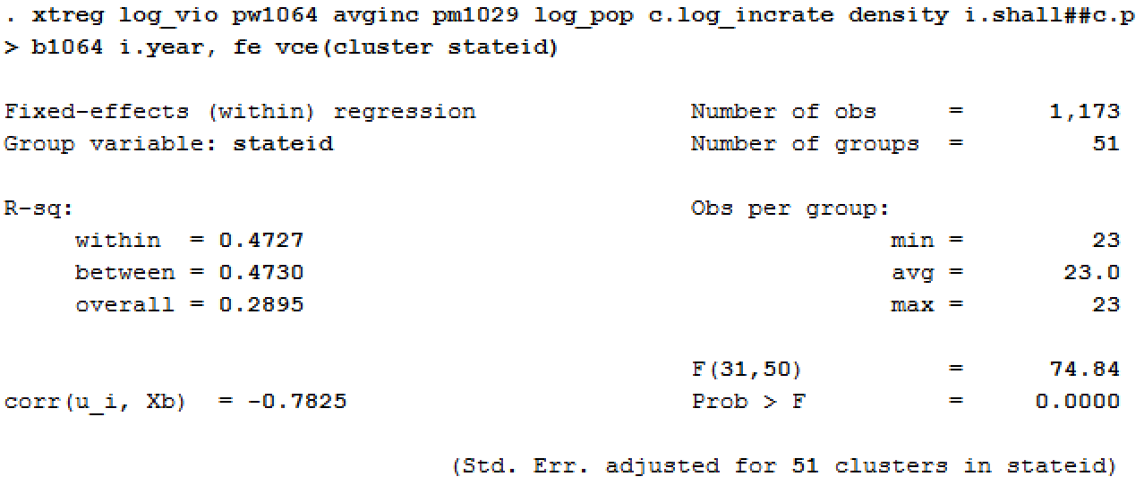

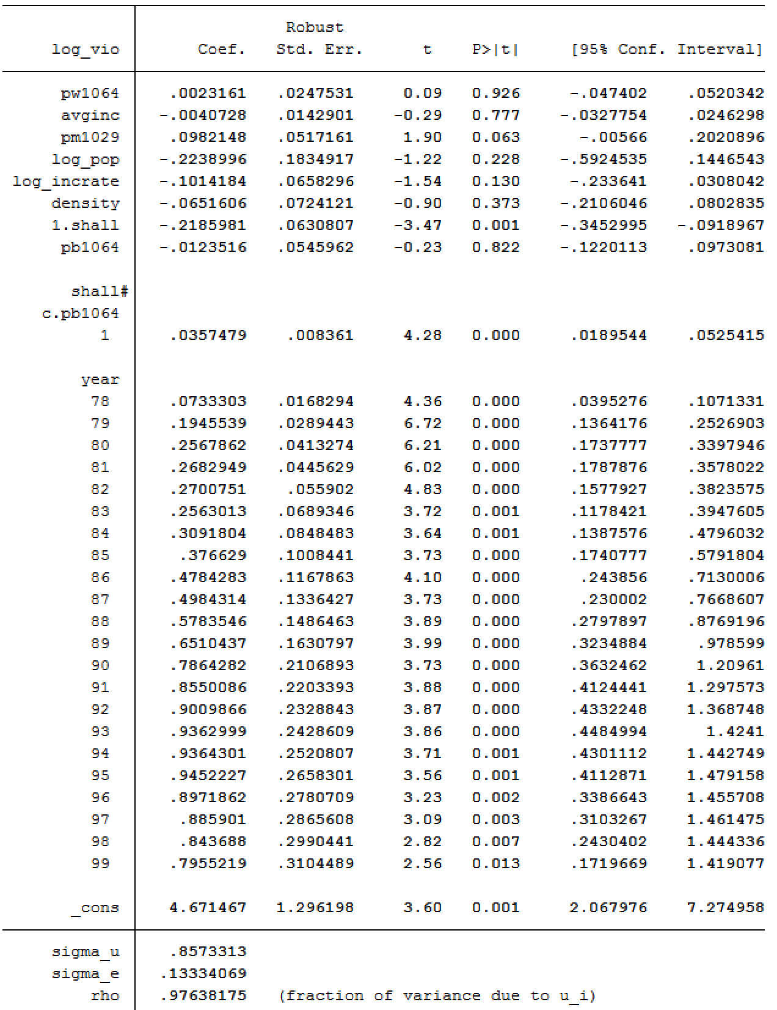

The adjusted R-squared value was calculated at .4584

The linear variable percentage of males is significant at the 10% significance level, while the variable shall and the interaction effect (shall*percentage of black population) along with the time periods from 1978 through 1999 were found to be significant at the 95% confidence level.

The interpretations of the coefficients are given below:

* As the years increase the violent crime rate increases.
* When a state has the shall law issued, there is an associated substantial decrease in violent crime rate.
* The percentage of males in the population has an increasing effect on the violent crime rate.
* When the shall law is implemented in a state, the percentage of black population on violent crime rate increases.

## Murder Rate

### Model 1:

We first run a Pooled Effect model with all the independent variables. The results are shown below:

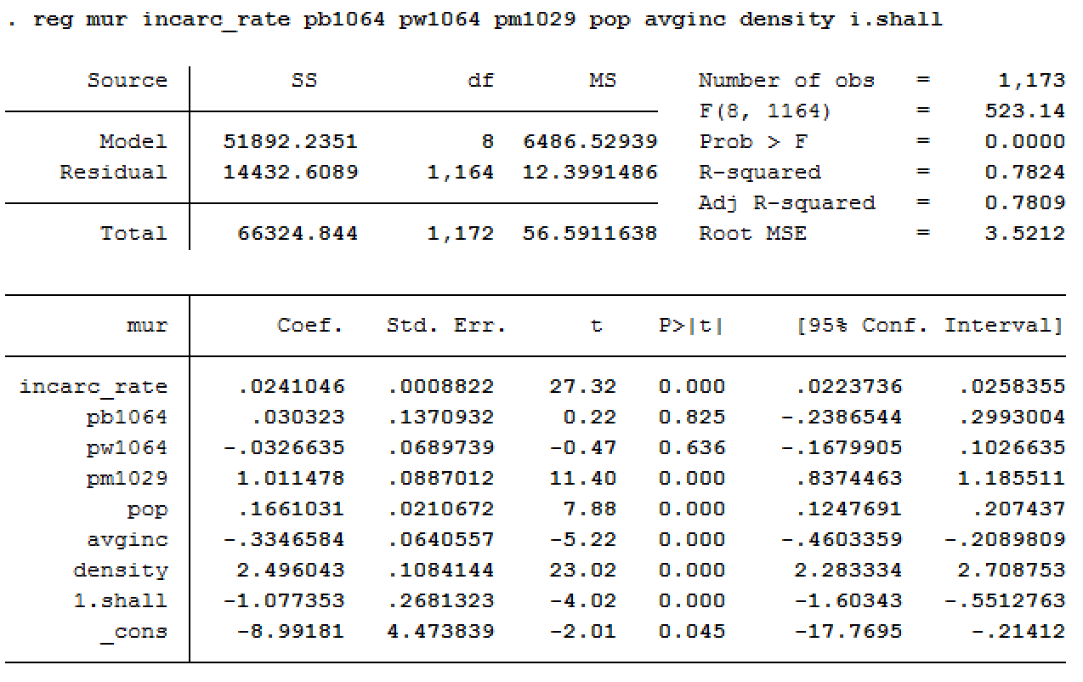

Our next step is to run the same model using the robust standard errors in order to account for the incorrect standard errors.

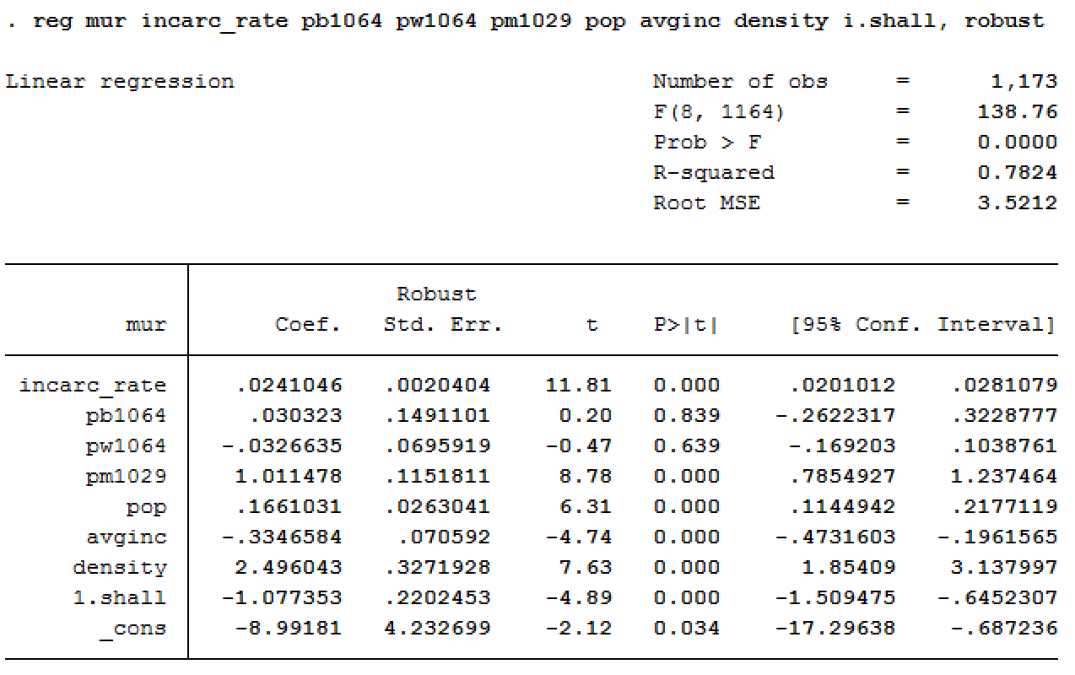

Due to the time effect included in a panel data, a variable x in time t has an influence over xt+1. Therefore, the assumption that the error terms between different time periods are not correlated is violated. Additionally, the variance of the error term may also be different over time.

To account for the problem of serial correlation which causes the coefficient estimates to become inefficient and the standard errors to be misleading, the next step is to run the panel data as a fixed and random effects model.

### Model 2:

A random effects model is run next as it has more degrees of freedom than the fixed effect model. Below are the results from the random effects model:

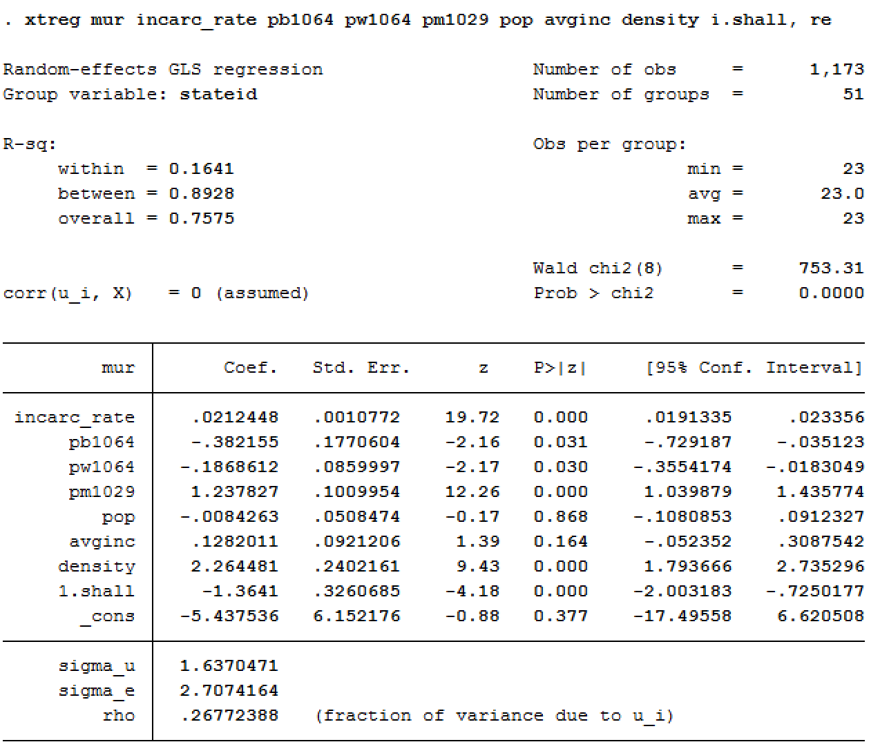

### Model 3:

The fixed effects model is run next. The results are as follows:

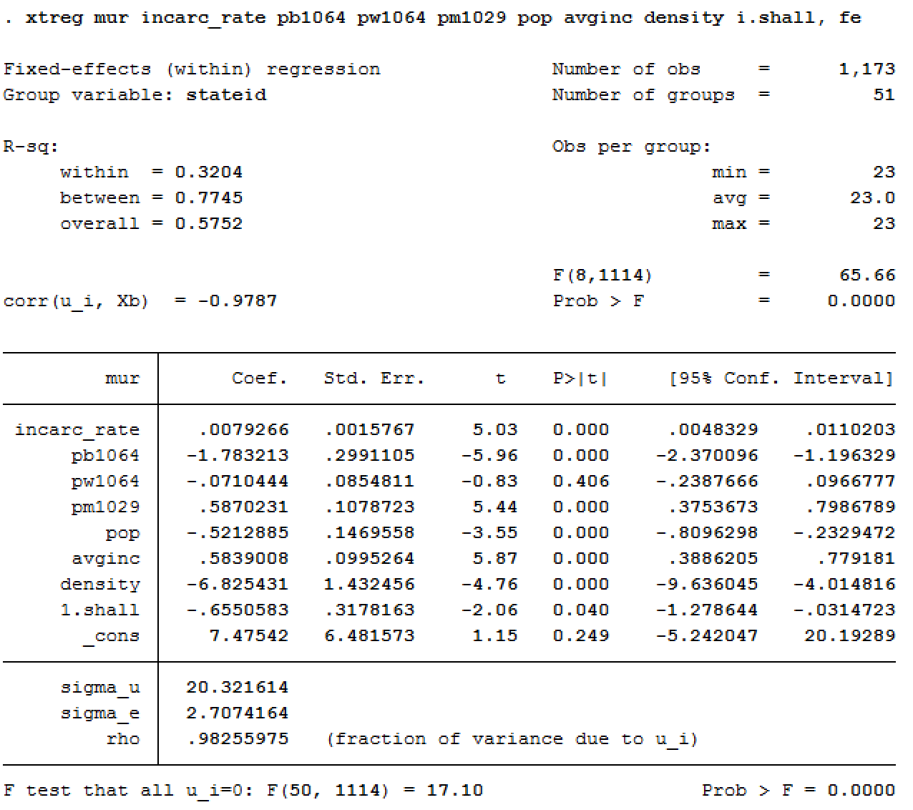

### Hausman Test:

Hausman’s test is run next to test if the independent variables of the random effects model are correlated with its error. Below are the results:

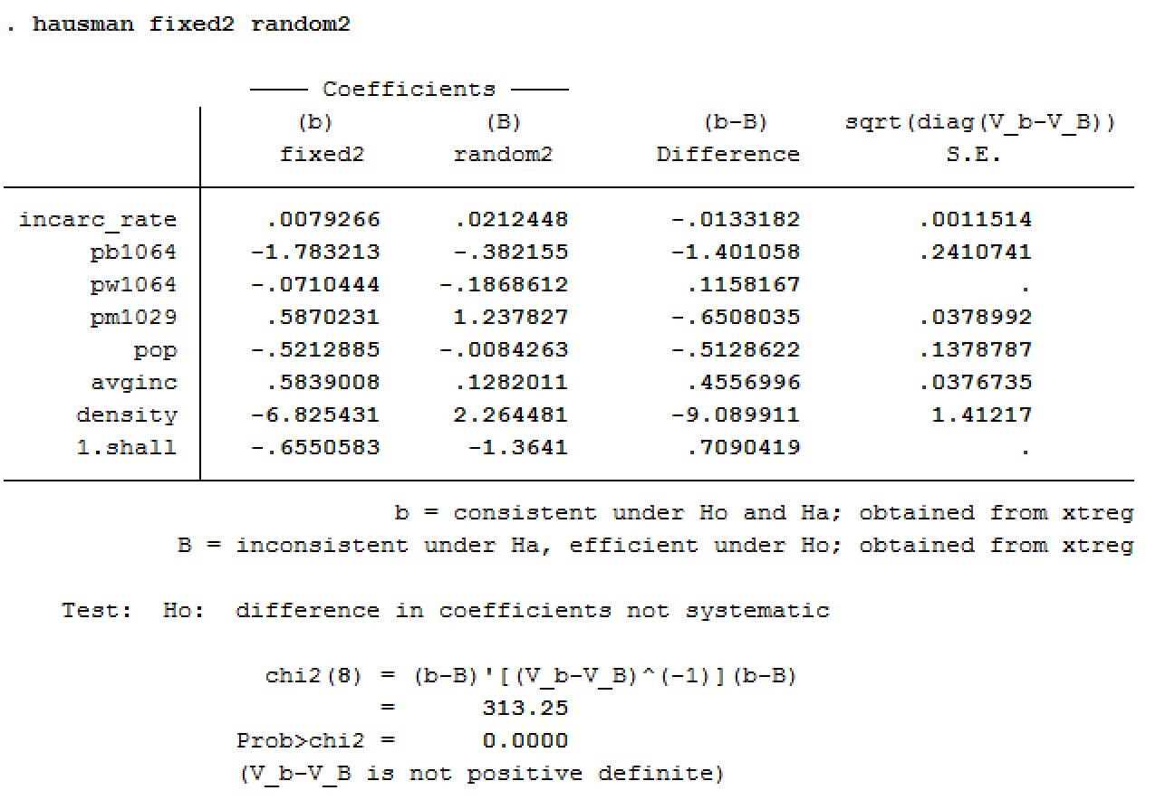

The p-value is < 0.00. So, we reject the null hypothesis that the coefficients of the fixed effect and the random effects are the same. Hence, the fixed effects model is selected.

### Model 4:

The fixed effect model is then run, with the Cluster Robust Standard Errors to get more efficient coefficients.

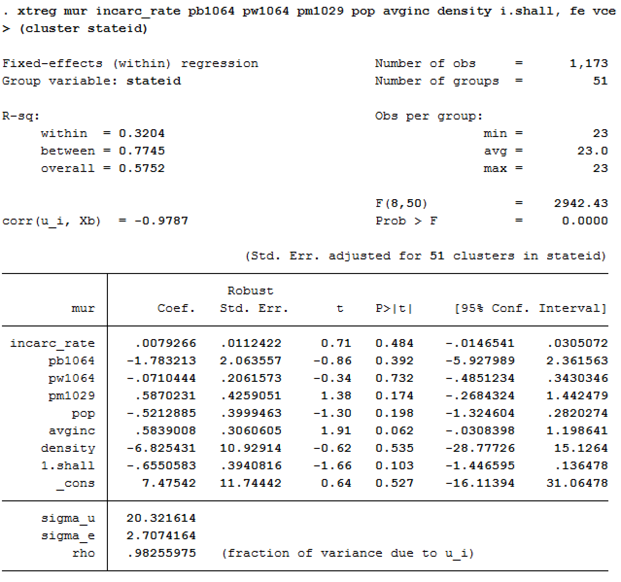

None of the variables are significant at a 95% confidence level.

### Model 5:

We then use the log form of density to account for the skewness observed in the histogram.

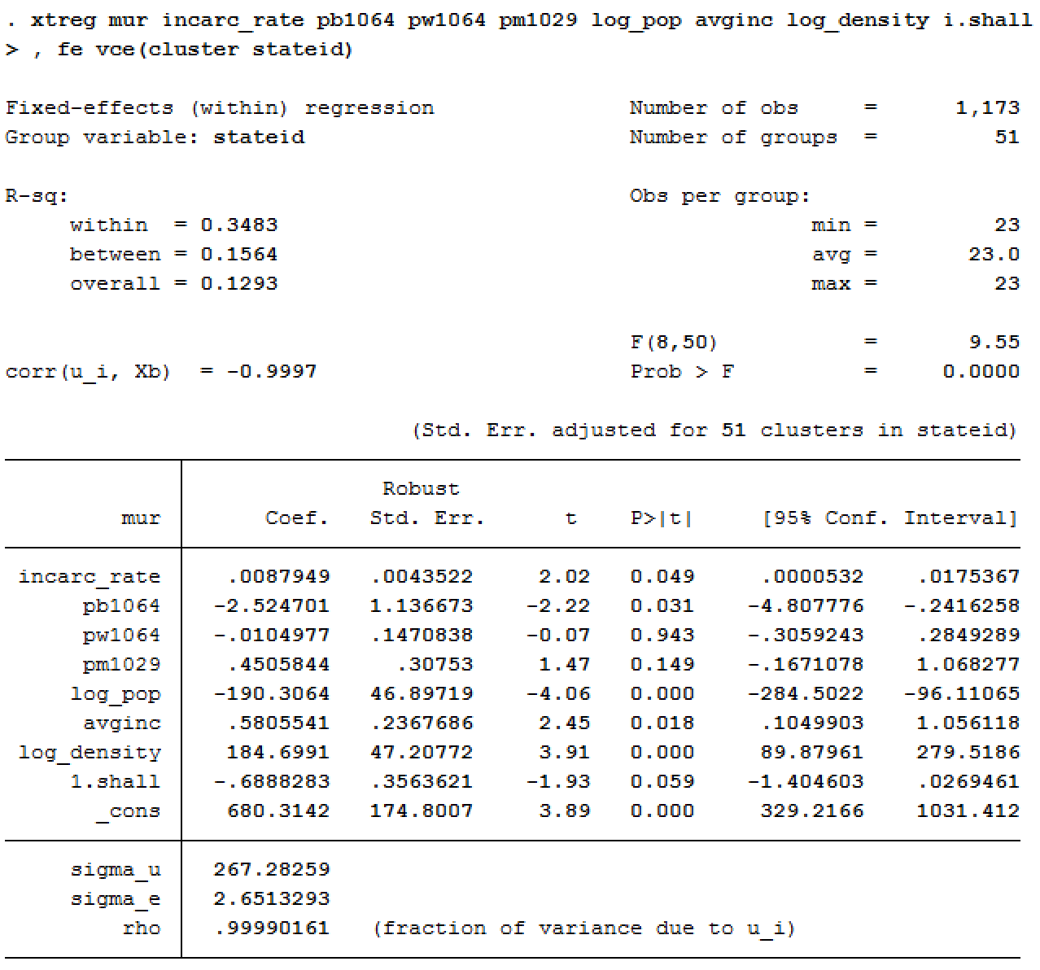

The variables incarceration rate, percentage of black population, log of population, average income and log of density are significant at the 95% confidence level.

### Model 6:

Dummy variable for each year is then added to check for time effects on the fixed effect model. The results are given below:

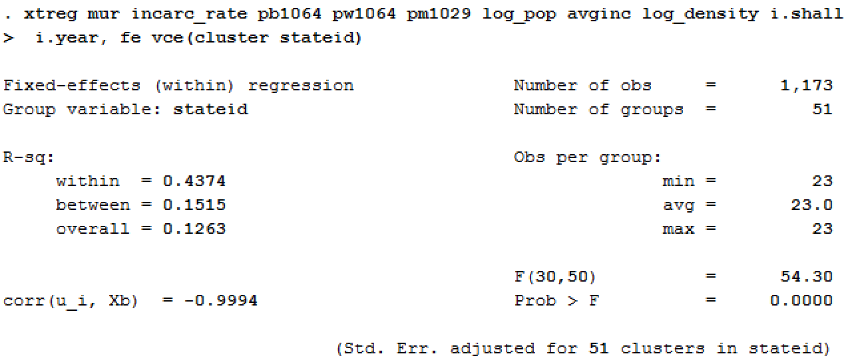

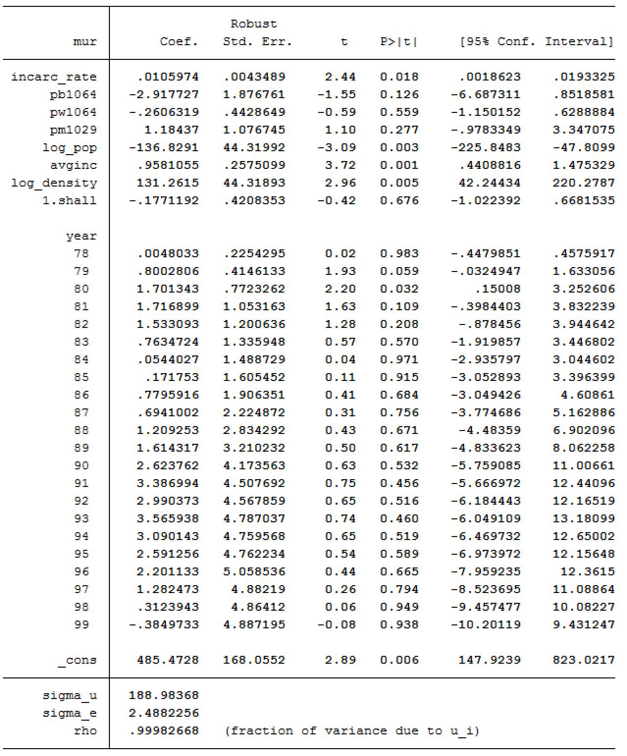

The percentage of black population became insignificant after including the time effect.

### F-Test:

An F-test is performed on the year dummy-variables, to assess if the fixed effect model is affected by the time component of the panel data.

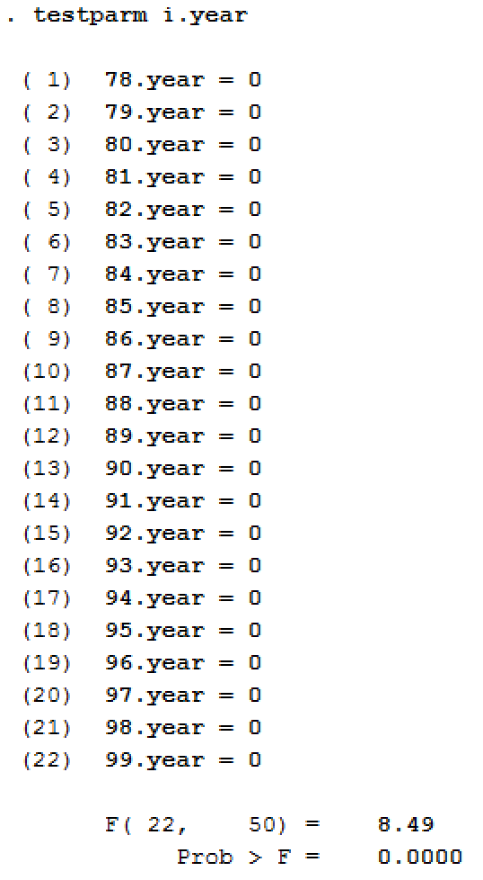

The results show that the time effects do indeed affect the fixed effect model.

### Model 7:

To understand the effect of non-linear relationship of the independent variables on murder rate, many combinations of interactions variables were included. The most meaningful interactions were found to be log of population*incarceration rate and log of density*percentage of black population. The results are as follows:

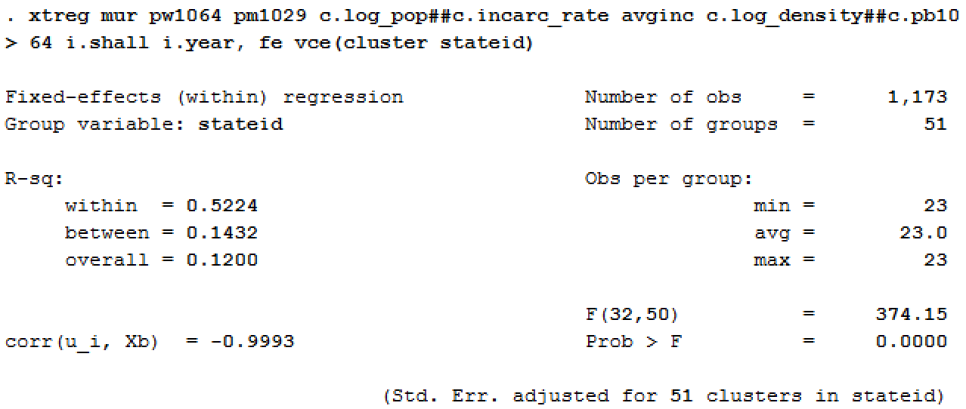

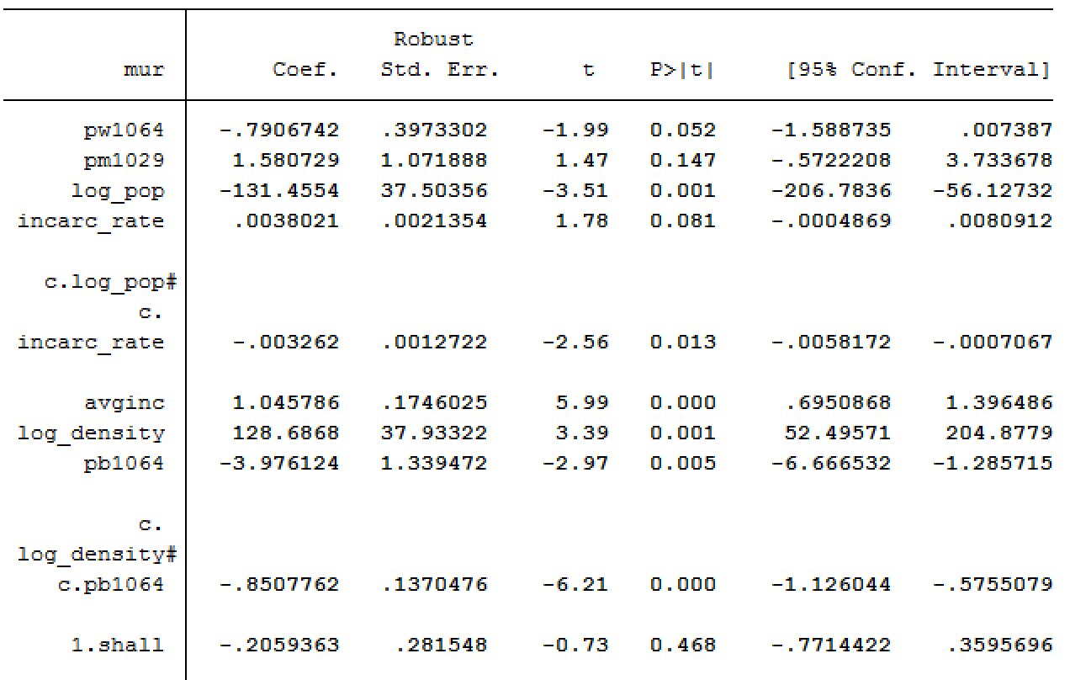

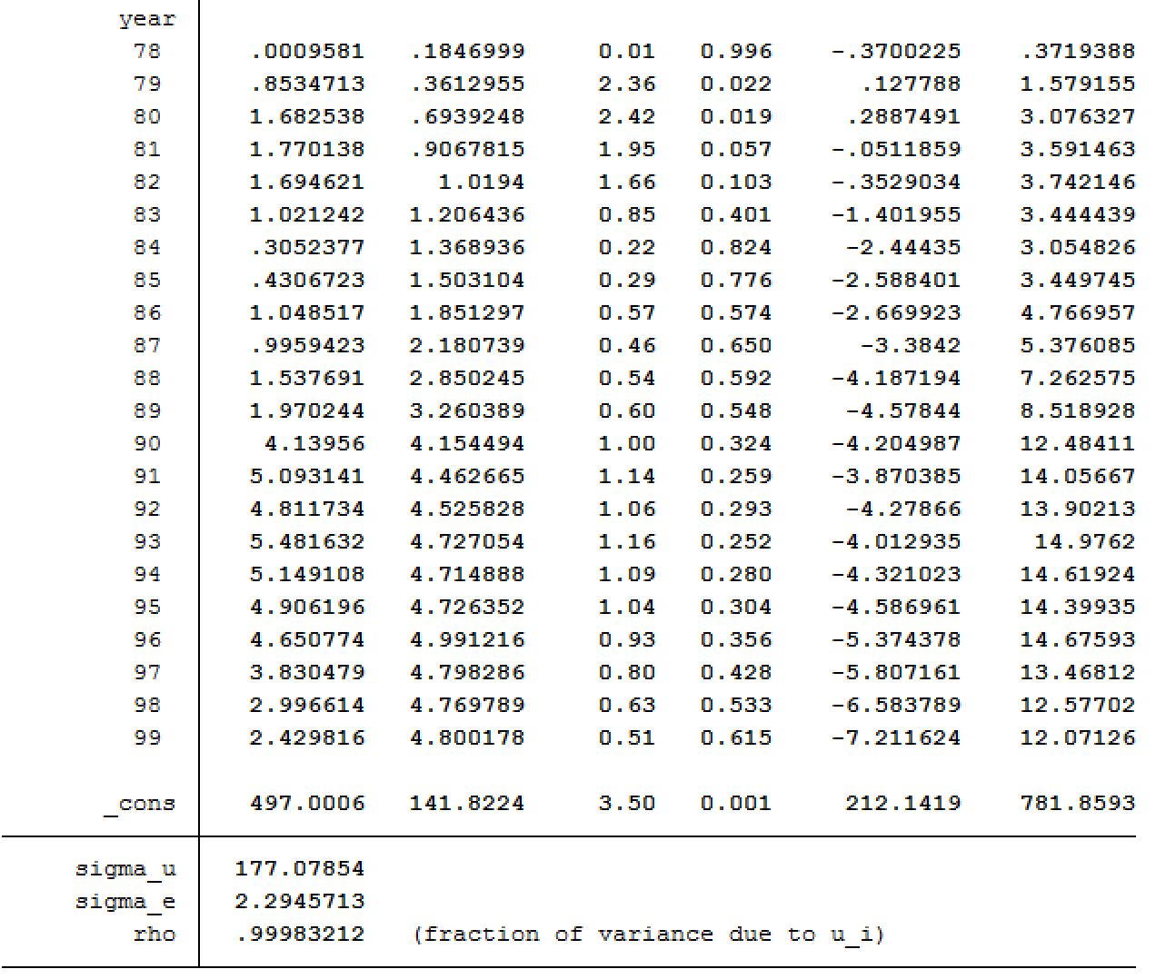

The adjusted R-squared value was found to be .509.

It was found that the independent variables incarceration rate and percentage of white population was significant at the 10% significance level, while log of population, average income, log of density and percentage of black population were significant at the 95% confidence level. Additionally, the interaction effects log of population*incarceration rate and log of density*percentage of black population were also significant. The time dummy variables were only significant for the year 1979 and 1980 at the 5% significant level and 1981 at the 10% significance level.

The interpretations of the coefficients are below:

* Increase in percentage of white population was inversely related with murder rate.
* Increase in incarceration rate had a very negligible negative effect on murder rate.
* When population increased by 1%, there was an associated 1.31 unit decrease in murder rate.
* Increase in average income leads to increase in murder rate by 1.04 units.
* More densely populated areas lead to an increase in murder rate. In specific, 1% increase in log of density is associated with a 1.28 unit increase in murder rate.
* Increase in percentage of black population by 1 unit leads to decrease in murder rate by 3.97 units.

## Robbery

### Model 1

We first run a Pooled Effect model with all the independent variables. The results are shown below:

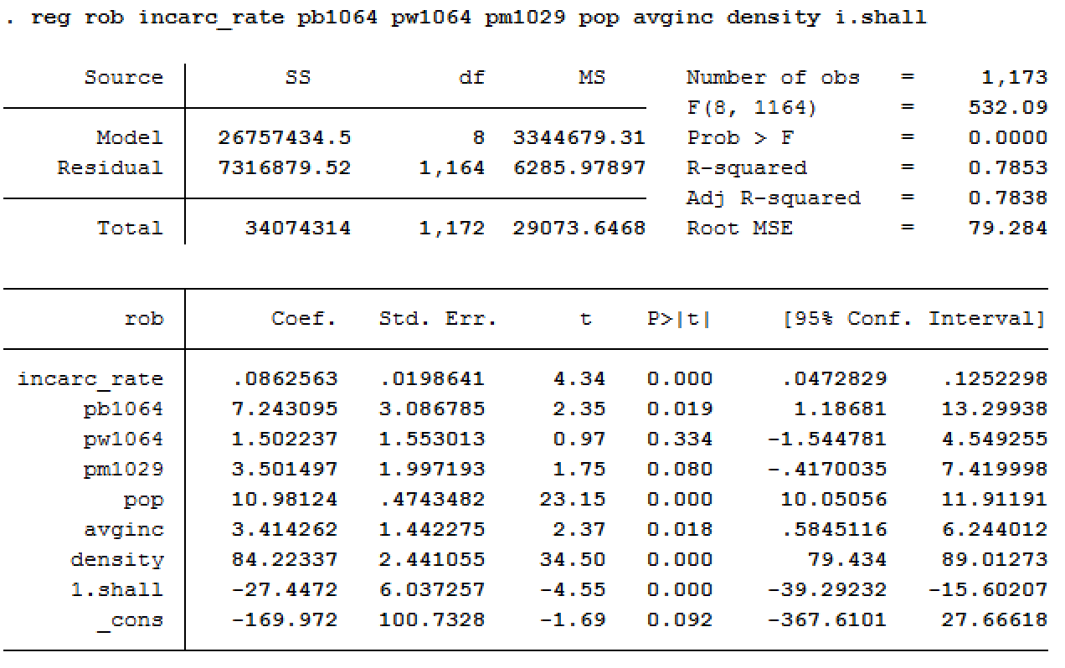

Our next step is to run the same model using the robust standard errors in order to account for the incorrect standard errors.

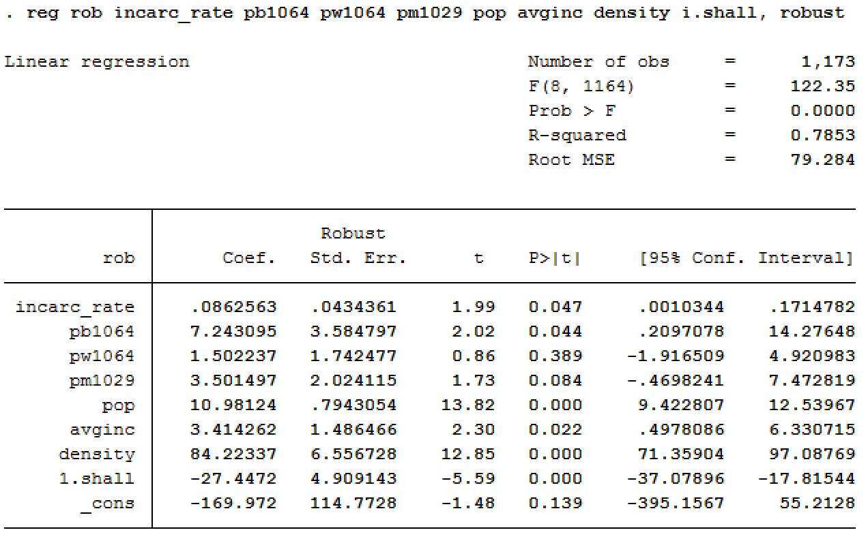

Due to the time effect included in a panel data, a variable x in time t has an influence over xt+1. Therefore, the assumption that the error terms between different time periods are not correlated is violated. Additionally, the variance of the error term may also be different over time.

To account for the problem of serial correlation which causes the coefficient estimates to become inefficient and the standard errors to be misleading, the next step is to run the panel data as a fixed and random effects model.

### Model 2:

A random effects model is run next as it has more degrees of freedom than the fixed effect model. Below are the results from the random effects model:

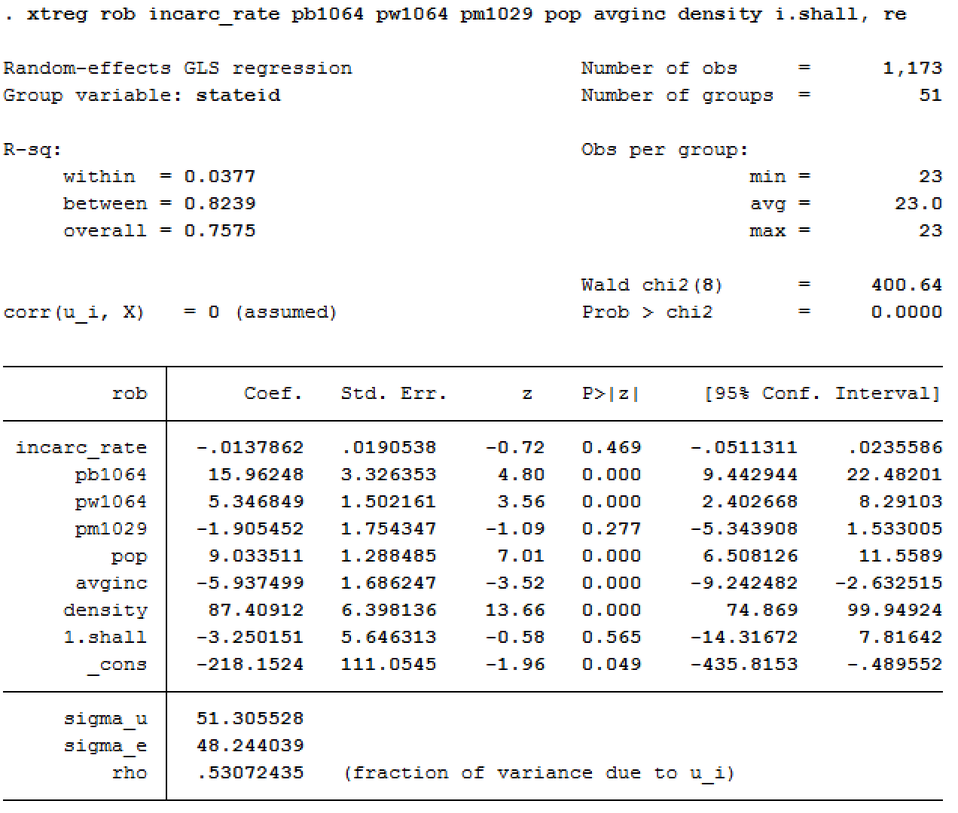

### Model 3:

The fixed effects model is run next. The results are as follows:

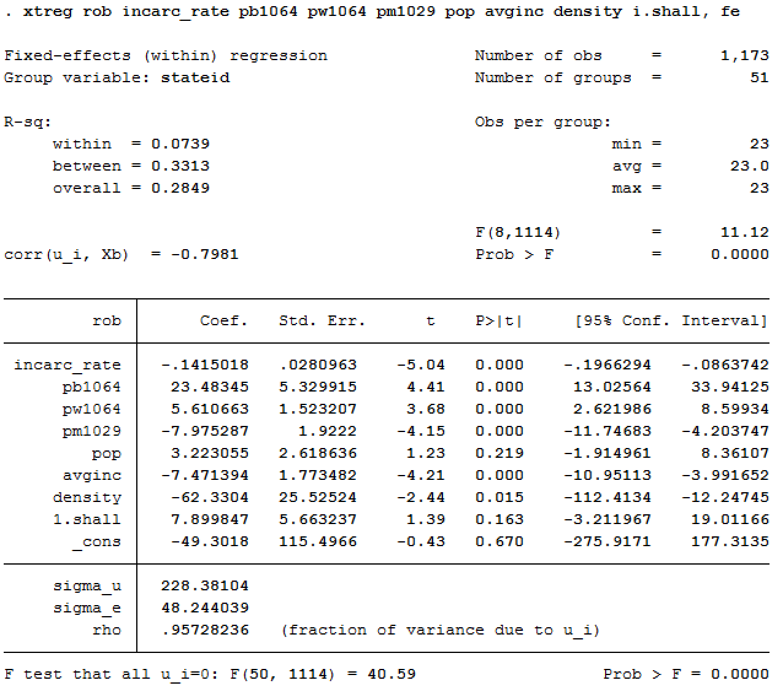

### Hausman Test:

Hausman’s test is run next to test if the dependent variables of the random effects model are correlated with its error. Below are the results:

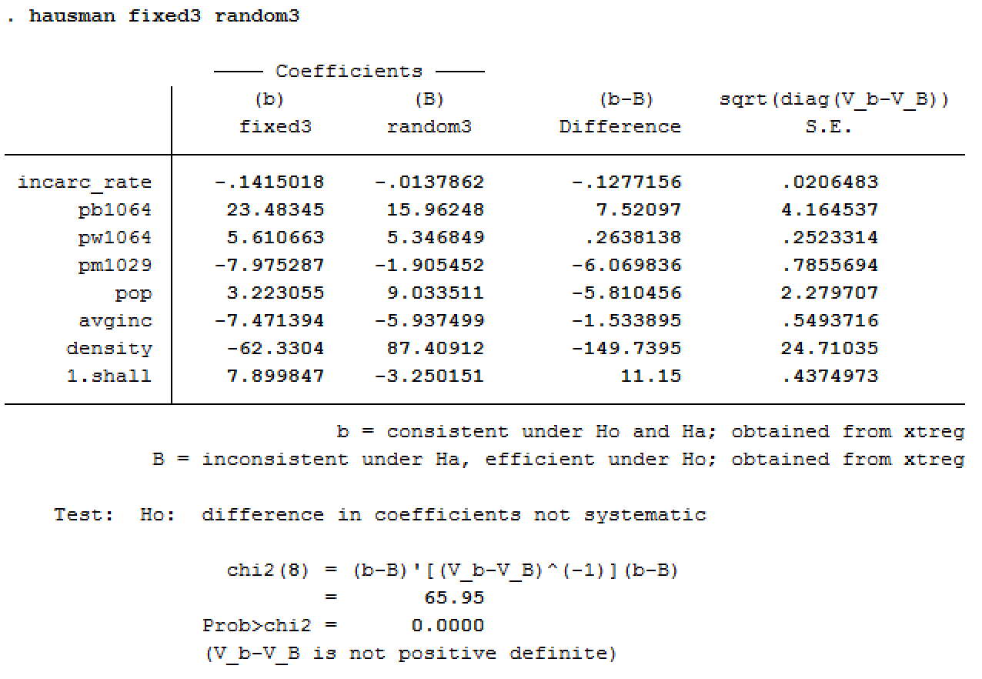

The p-value is < 0.00. So, we reject the null hypothesis that the coefficients of the fixed effect and the random effects are the same. Hence, the fixed effects model is selected.

### Model 4:

The fixed effect model is then run, with the Cluster Robust Standard Errors to get more efficient coefficients.

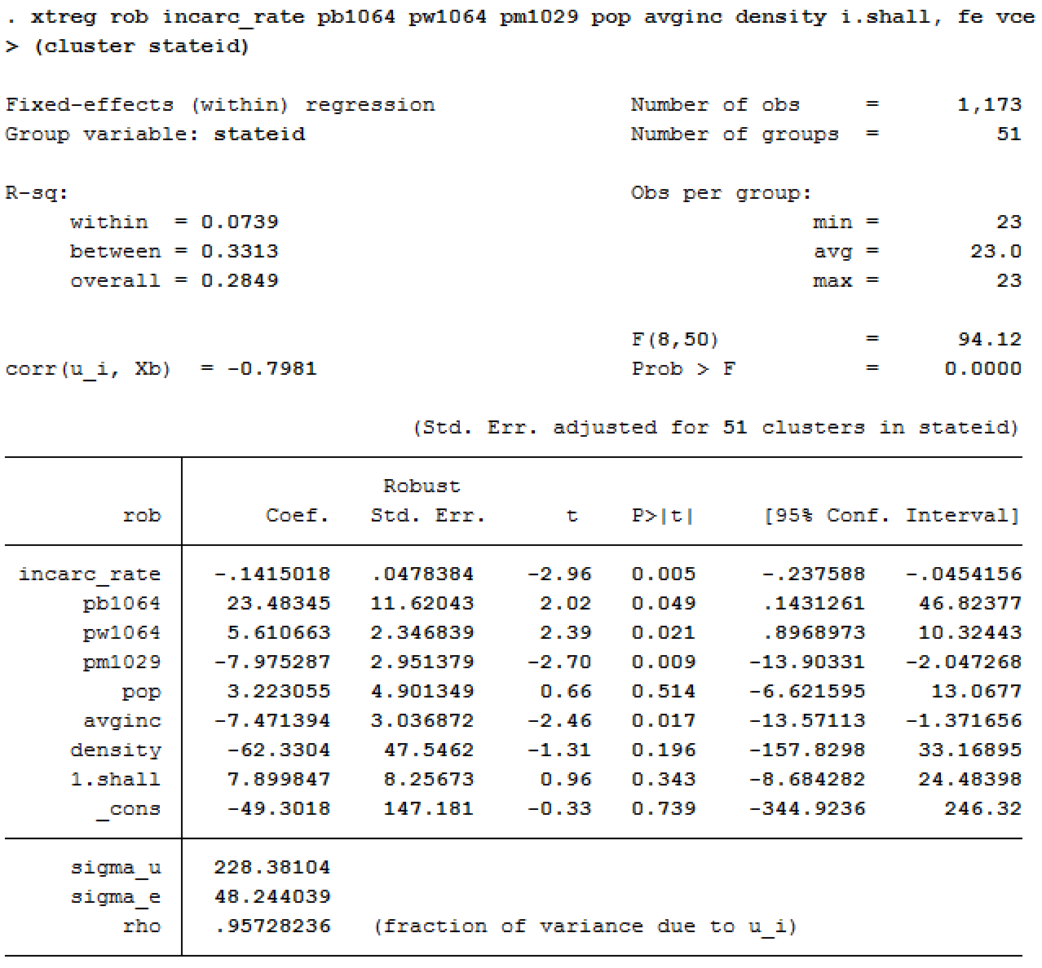

The variables incarceration rate, percentage of black, white and male populations and average income are significant at the 95% confidence level.

### Model 5:

Dummy variable for each year is then added to check for time effects on the fixed effect model. The results are given below:

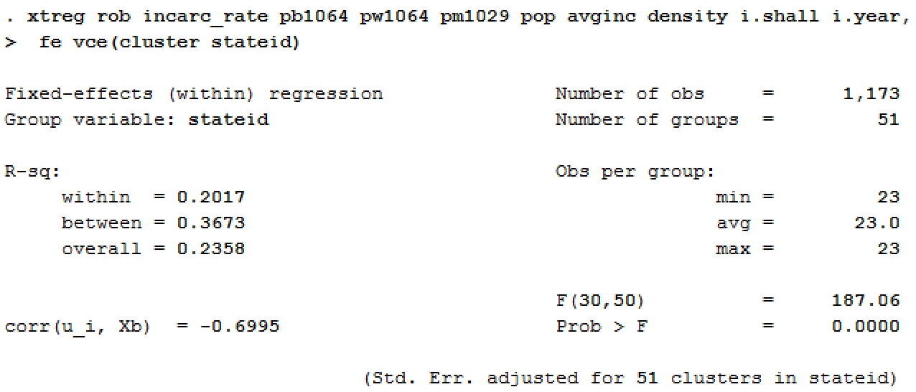

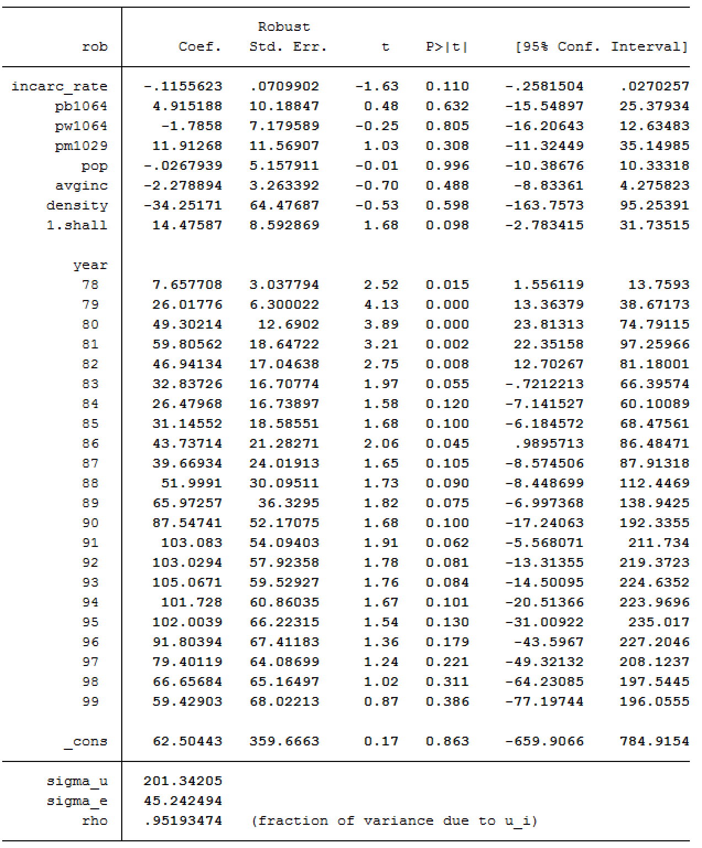

### F-Test:

An F-test is performed on the year dummy-variables, to assess if the fixed effect model is affected by the time component of the panel data.

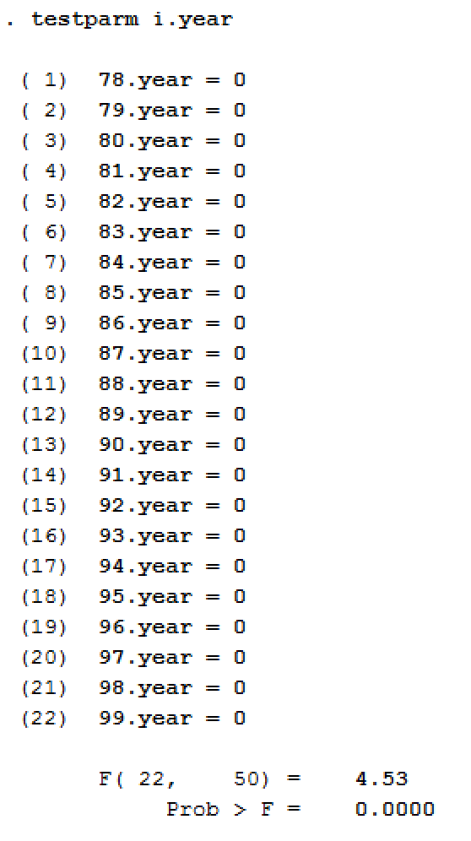

The results show that the time effects do indeed affect the fixed effect model.

### Model 6:

To understand the effect of non-linear relationship of the independent variables on violent crime rates, various interaction variables were added. While most of the interaction effects were found to be insignificant, the best model was found to include the interaction effects population*percentage of black population, average income*density and the density*density. The output is as follows:

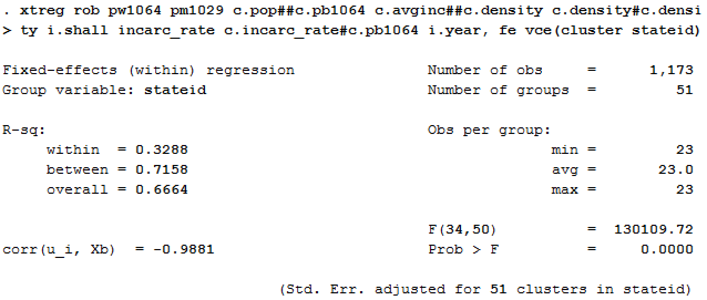

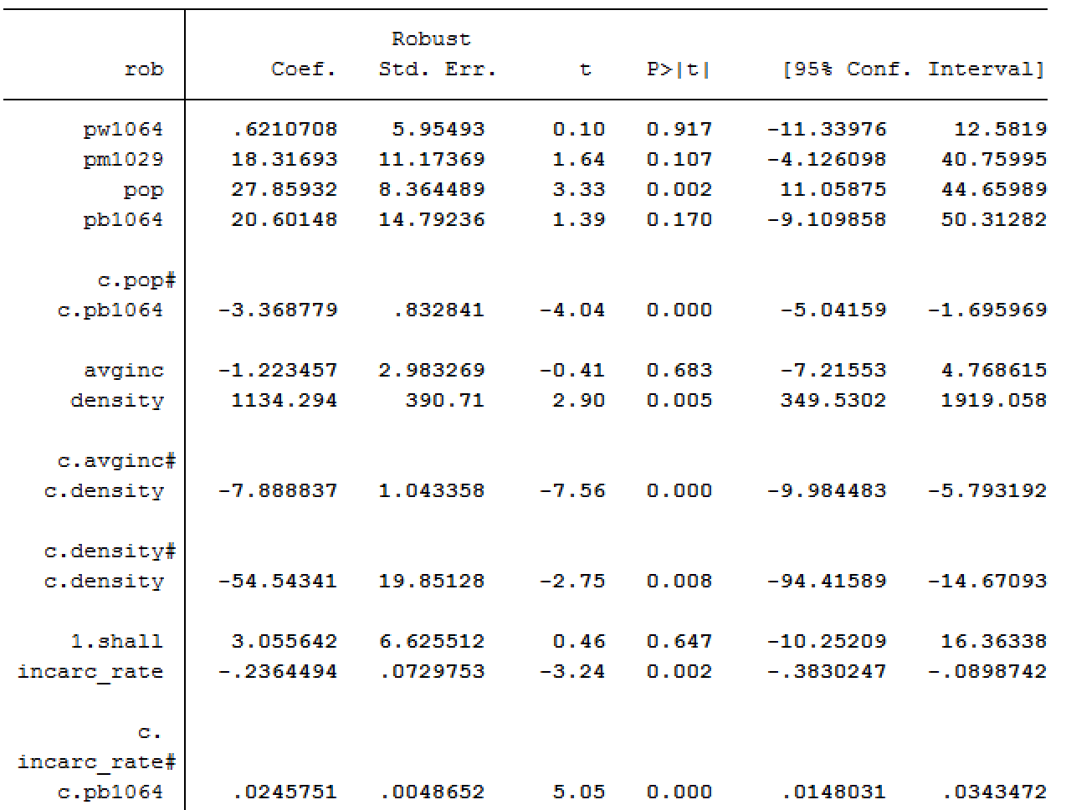

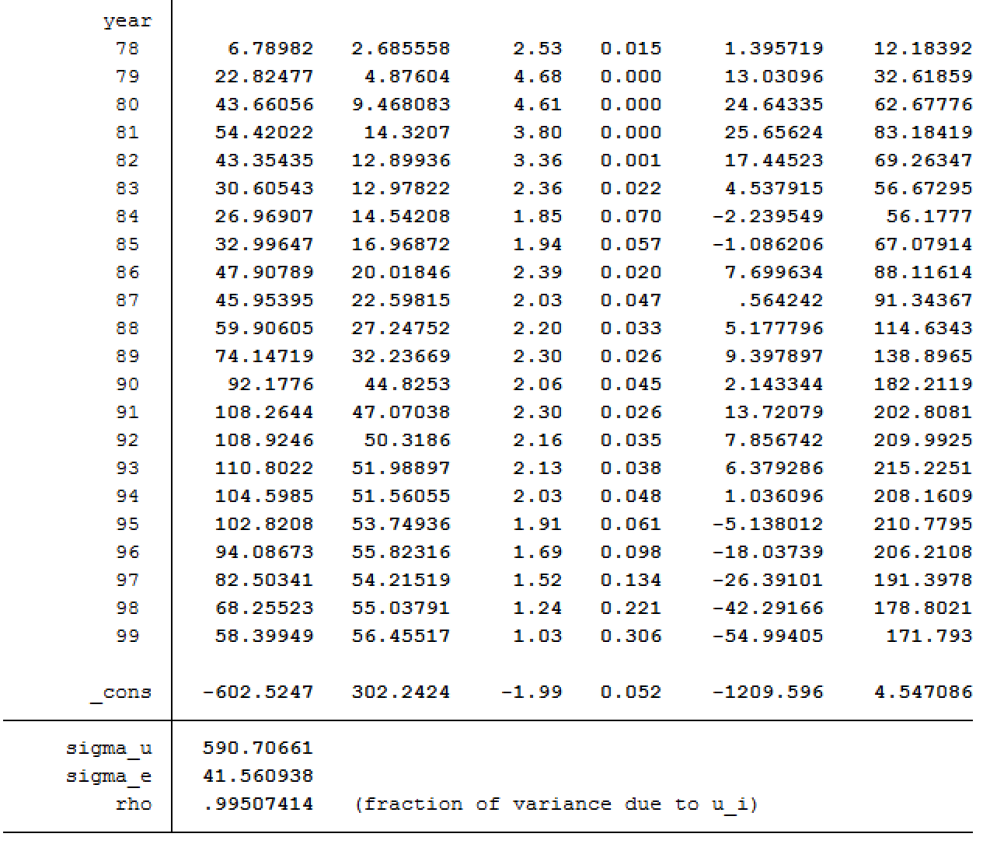

The adjusted R-squared value was found to be .3087.

We find that the independent variables density, population and incarceration rate are significant at the 95% confidence level along with the interaction effects population*percentage of black population, average income*density and density*density. The time dummy variables for the years 1978 to 1996 are significant at the 90% confidence level.

The interpretations of the coefficients are below:

* Increase in density is associated with a substantial increase in robbery rate.
* Increase in population is also associated with an increase in robbery rate.
* When more people are incarcerated, there is a decline in the robbery rate.
* In a state with more population, if the percentage of black population increases, the rate at which robbery rate increases is diminishing. For a state with lower population, when the percentage of black people increases, increase in robberies is more compared to a state with a high population.
* When the average income of a densely populated area is high, robbery rate declines.
* As the population density of a state increases, the marginal rate at which it affects the increase in robbery rate is diminishing.

# Conclusion:

The pooled OLS model led to inflated estimators due to endogeneity, which was caused by the presence of individual state and time effects. These limitations were controlled for by using the state fixed and time fixed model. The state fixed aspect took into account each of their unique heterogeneity, whereas the time fixed aspect took into account effects that vary across time but not across states, like federal policies that affected all states.

There was also the limitation of limited data. With more data, even more variance could have been accounted for leading to more confident interpretations of the coefficients of the independent variables.

Since many of the features could not strongly explain the different types of crime rates, there exists a possibility of missing variables. Adding additional variables like unemployment rates, or a proxy for cultural attitude towards usage of guns may help engender a better model.

Based on the findings from the models created for the different crime rates, we find that the shall-issue law and the incarceration rate have no significant effect on murder rates and violent crime rates. We do find that shall-issue law significantly affects robbery rate at a 95% confidence level, by reducing it by 29.3 units when the law is adopted.

## Appendix

### Stata Code

**Basic Analysis

summarize vio mur rob incarc_rate pb1064 pw1064 pm1029 pop avginc density shall

xtset stateid year

xtsum vio mur rob incarc_rate pb1064 pw1064 pm1029 pop avginc density shall

corr vio mur rob incarc_rate pb1064 pw1064 pm1029 pop avginc density shall

**Dummy variables for time

summarize i.year

testparm i.year

*Log variables

histogram vio

gen log_vio = log(vio)

histogram log_vio

histogram mur

gen log_mur = log(mur)

histogram log_mur

histogram rob

gen log_rob = log(rob)

histogram log_rob

histogram pop

gen log_pop = log(pop)

histogram log_pop

histogram density

gen log_density = log(density)

histogram log_density

histogram incarc_rate

gen log_incrate = log(incarc_rate)

histogram log_incrate

**Violent Crime Rate

*Pooled OLS

reg vio incarc_rate pb1064 pw1064 pm1029 pop avginc density i.shall

reg vio incarc_rate pb1064 pw1064 pm1029 pop avginc density i.shall, robust

*Random Effects Model

xtreg vio incarc_rate pb1064 pw1064 pm1029 pop avginc density i.shall, re

estimates store random

*Fixed-Effects Model

xtreg vio incarc_rate pb1064 pw1064 pm1029 pop avginc density i.shall, fe

estimates store fixed

*Hausman Test

hausman fixed random

*Robust Standard Errors

xtreg vio incarc_rate pb1064 pw1064 pm1029 pop avginc density i.shall, fe vce(cluster stateid)

xtreg log_vio log_incrate pb1064 pw1064 pm1029 log_pop avginc density i.shall, fe vce(cluster stateid)

*Dummy variables for time

xtreg log_vio log_incrate pb1064 pw1064 pm1029 log_pop avginc density i.shall i.year, fe vce(cluster stateid)

*Interaction Variables

xtreg log_vio pw1064 avginc pm1029 log_pop c.log_incrate density i.shall##c.pb1064 i.year, fe vce(cluster stateid)

ereturn list

**Murder Rate

*Pooled OLS

reg mur incarc_rate pb1064 pw1064 pm1029 pop avginc density i.shall

reg mur incarc_rate pb1064 pw1064 pm1029 pop avginc density i.shall, robust

*Random Effects Model

xtreg mur incarc_rate pb1064 pw1064 pm1029 pop avginc density i.shall, re

estimates store random2

*Fixed-Effects Model

xtreg mur incarc_rate pb1064 pw1064 pm1029 pop avginc density i.shall, fe

estimates store fixed2

*Hausman Test

hausman fixed2 random2

*Robust Standard Errors

xtreg mur incarc_rate pb1064 pw1064 pm1029 pop avginc density i.shall, fe vce(cluster stateid)

xtreg mur incarc_rate pb1064 pw1064 pm1029 log_pop avginc log_density i.shall, fe vce(cluster stateid)

*Dummy variables for time

xtreg mur incarc_rate pb1064 pw1064 pm1029 log_pop avginc log_density i.shall i.year, fe vce(cluster stateid)

*Interaction Variables

xtreg mur pw1064 pm1029 c.log_pop##c.incarc_rate avginc c.log_density##c.pb1064 i.shall i.year, fe vce(cluster stateid)

ereturn list

**Robbery Rate

*Pooled OLS

reg rob incarc_rate pb1064 pw1064 pm1029 pop avginc density i.shall

reg rob incarc_rate pb1064 pw1064 pm1029 pop avginc density i.shall, robust

*Random Effects Model

xtreg rob incarc_rate pb1064 pw1064 pm1029 pop avginc density i.shall, re

estimates store random3

*Fixed-Effects Model

xtreg rob incarc_rate pb1064 pw1064 pm1029 pop avginc density i.shall, fe

estimates store fixed3

*Hausman Test

hausman fixed3 random3

*Robust Standard Errors

xtreg rob incarc_rate pb1064 pw1064 pm1029 pop avginc density i.shall, fe vce(cluster stateid)

*Dummy variables for time

xtreg rob incarc_rate pb1064 pw1064 pm1029 pop avginc density i.shall i.year, fe vce(cluster stateid)

*Interaction Variables

xtreg rob pw1064 pm1029 c.pop##c.pb1064 c.avginc##c.density c.density#c.density i.shall incarc_rate c.incarc_rate#c.pb1064 i.year, fe vce(cluster stateid)

ereturn list